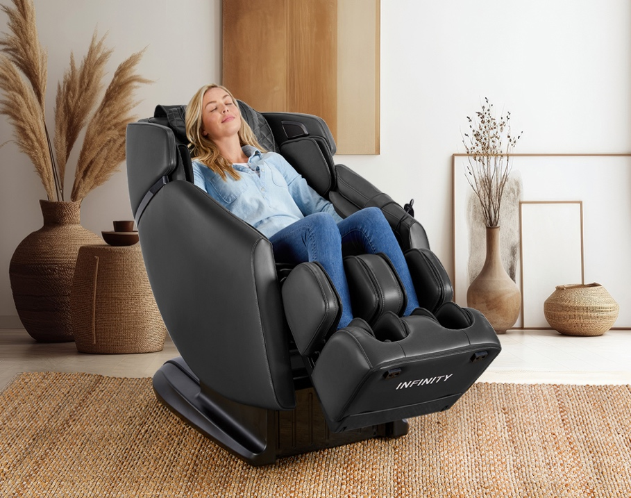

The Infinity Riage® 4D massage chair is designed with the latest technology. The sophisticated 4D back mechanism will make you feel like you’re receiving a massage from a professional massage therapist. The Riage 4D is appointed with luxurious materials and a high end fit and finish found on all Infinity massage chairs… yet it's remarkably affordable.

The Infinity Riage® 4D will make your muscles feel relieved and rejuvenated from head to toe, giving you the first-class feeling that you deserve. Ascend into your happy place with massage everyday.

**5 Year Residential Limited Warranty**

* Unlimited USA-based customer & technical support
* 5 Year structural framework warranty
* No-cost replacement on covered parts for 3 years
* Complete Care/No-cost parts & labor

(in-home, if necessary) for 1 year

* Labor and parts extension to 3 and 5 years available
* 4D Back Massage Mechanism
* L-Track
* Airbag Compression Therapy
* Dual Reflexology Foot Rollers
* 2 Levels of Weightless Zero Gravity Recline
* Menu driven TFT LCD display for easy navigation
* SootheMe™ Sound Therapy
* Premium Bluetooth Speakers
* 10 Auto Programs
* Truefit™ Body Scanning
* Zero Wall Fit™ Space-Saving Technology
* Lumbar Heat
* Quick Access Control Panel

**Measurements**

* Chair Width: 30″
* Chair Weight: 238 lbs.

### **Upright**

* Chair Length: 59″
* Chair Height: 47″

### **Reclined**

* Chair Length: 69″
* Chair Height: 41″

**RIAGE 4D**

**LEARN MORE**